DBMS -MINI PROJECT

TITLE OF THE PROJECT:

**PHARMACY MANAGEMENT SYSTEM**



**Short Description and Scope of the Project**

Any system used in a pharmacy to aid in the automation of the pharmacy workflow is referred to as pharmacy management software. This involves doing things like assessing prescriptions and producing medications, managing the inventory and ordering drugs, billing and discovering incompatibilities, and other things while adhering to legal requirements. These are merely the conventional tasks that are automatable. The addition of many more features could give the pharmacy a competitive edge by improving the patient experience and luring clients with more individualised and interesting care. In the section that follows, we will go into greater depth regarding these features. We hereby take prescription from

Customer who distributes the medicines they have got from the

Company Which they have ordered for it. If the company has

medicines, it will distribute the ordered drugs with batch number

and expire date.

We intend to make it to greater scope in nearby future covering some basic problem solving for the society.

Enhancing the performance of pharmacists. The majority of a pharmacist's working hours are spent dispensing medications.

Enhancing the results of patient health. A PMS can directly or indirectly assist patients who are seeking counselling from pharmacists in receiving better counselling. Pharmacists can interact with customers online via a patient portal in addition to spending more time with them in person.

Preventing medical fraud is one of the main aspects in the future.

**ER Diagram**

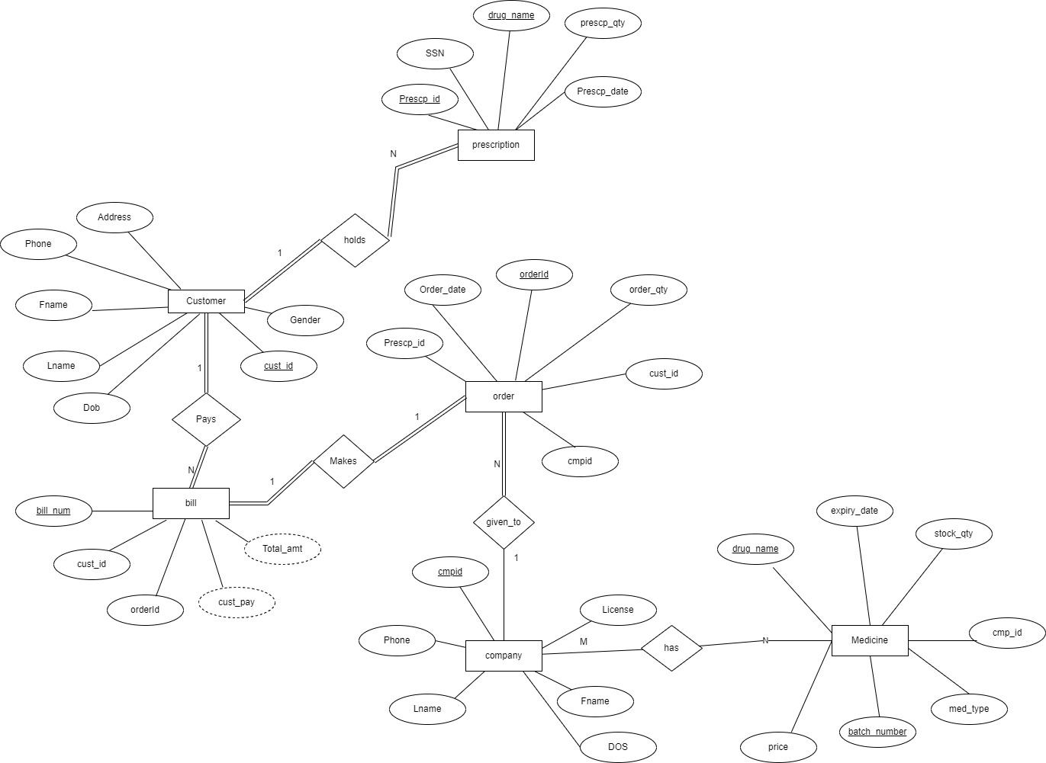

**Relational Schema**

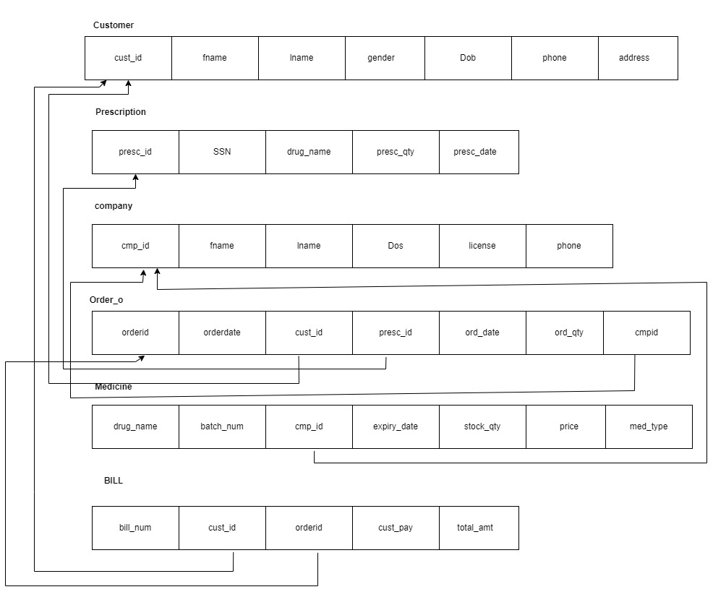

**DDL statements - Building the database**

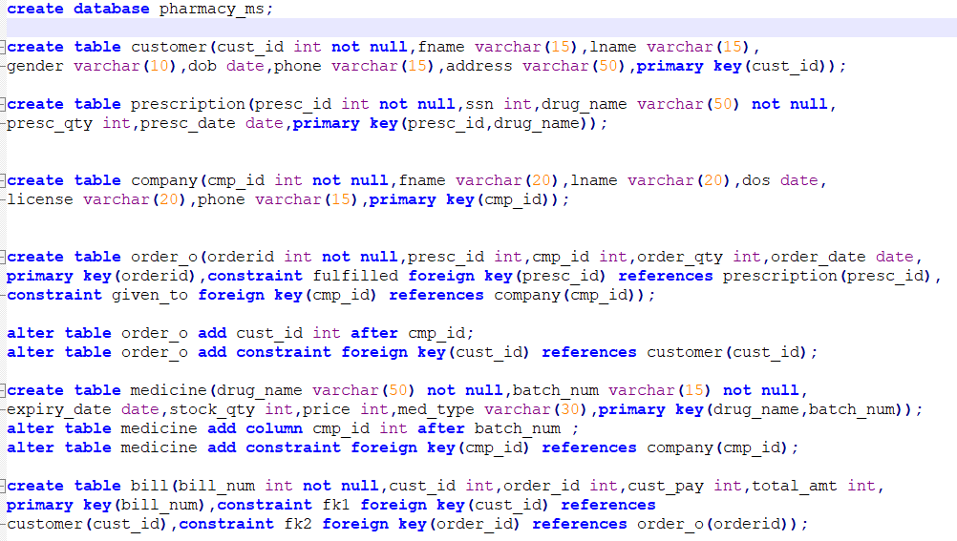

**Populating the Database**

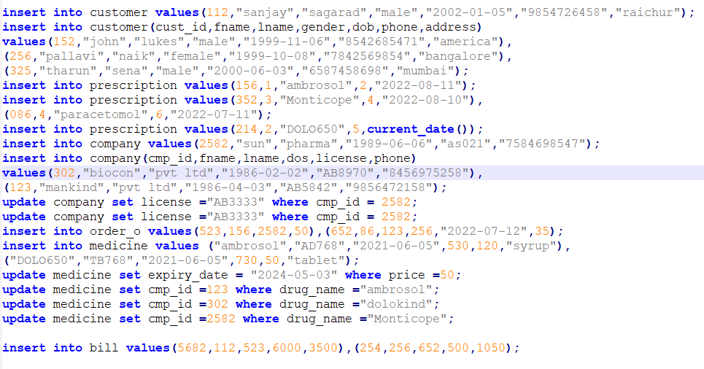

**Join Queries**

**Showcase at least 4 join queries Write the query in English Language, Show the equivalent SQL statement and also a screenshot of the query and the results**

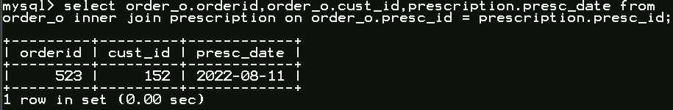

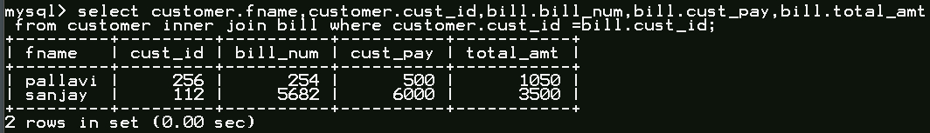

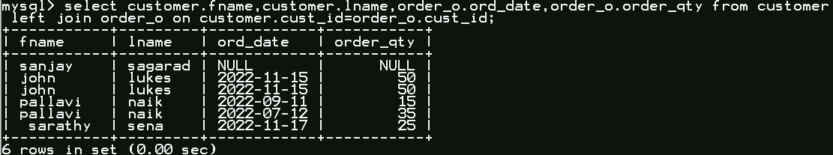

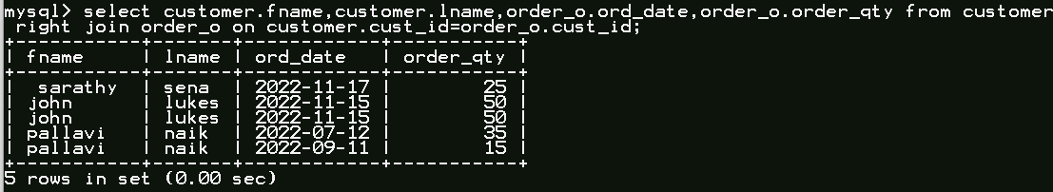

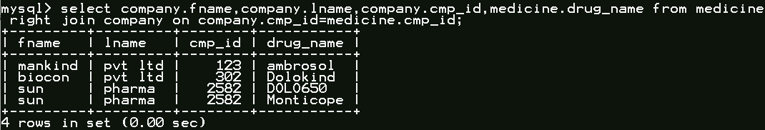

**Aggregate Functions**

Showcase at least 4 Aggregate function queries Write the query in English Language, Show the equivalent SQL statement and also a screenshot of the query and the results

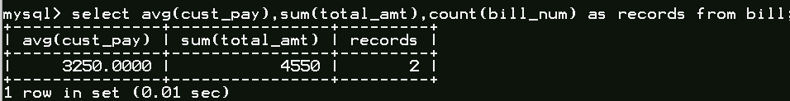

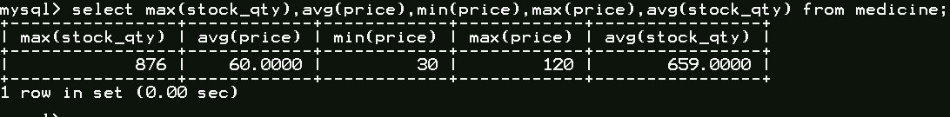

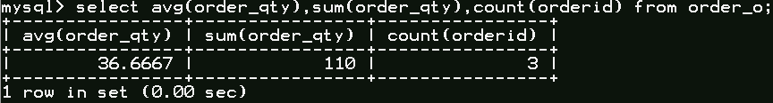



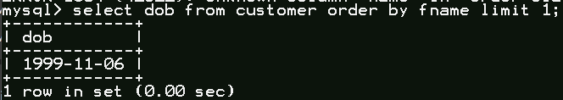

**Set Operations**

Showcase at least 4 Set Operations queries Write the query in English Language, Show the equivalent SQL statement and also a screenshot of the query and the results

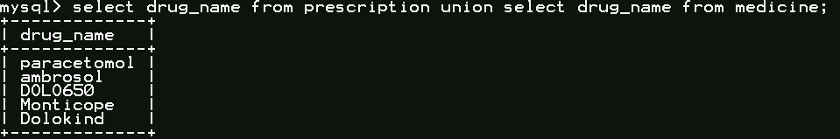

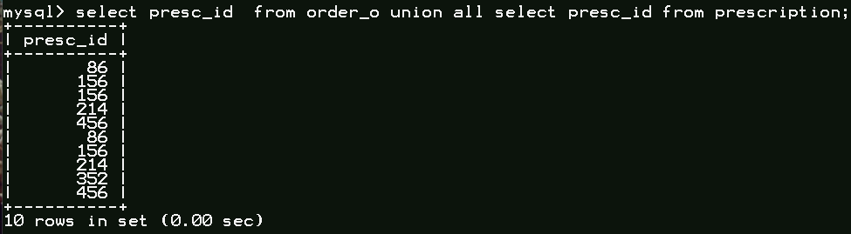

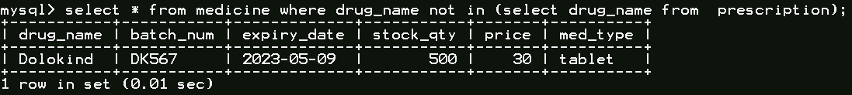

**NOT IN** has been used for Except, we can even use inner join to get Difference where we have to specify column of that table is equal to null.

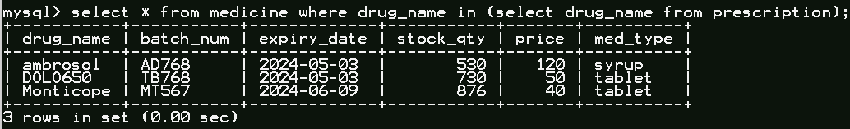

**IN** has been used for intersection, we can even use inner join to get intersection.

**Functions and Procedures**

Create a Function and Procedure. State the objective of the function / Procedure. Run and display the results

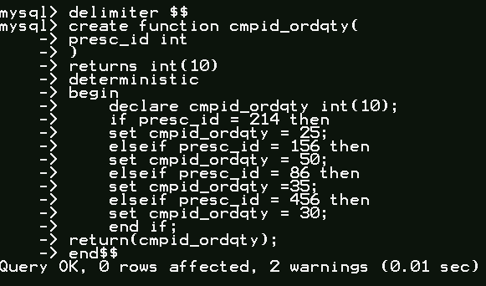

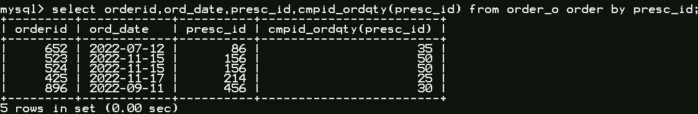

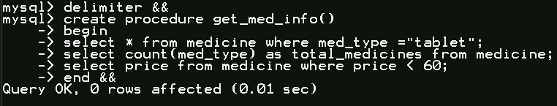

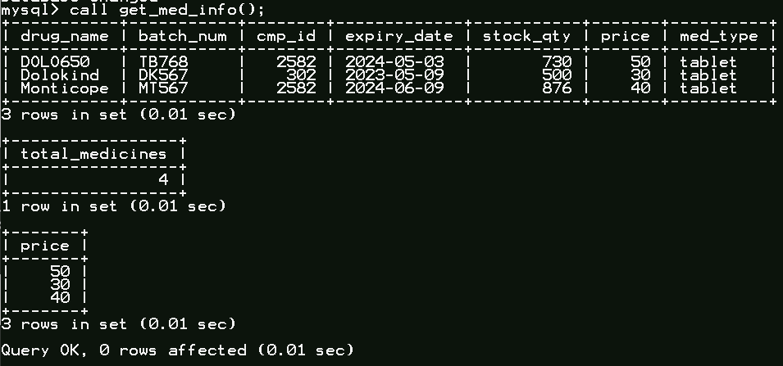

**Triggers and Cursors**

Create a Trigger and a Cursor. State the objective. Run and display the results.

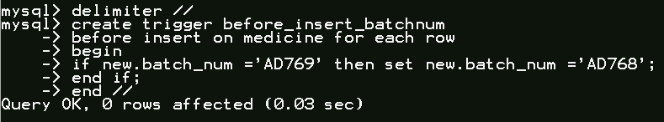



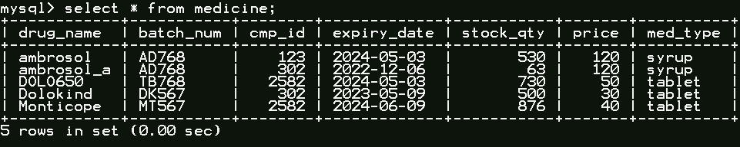

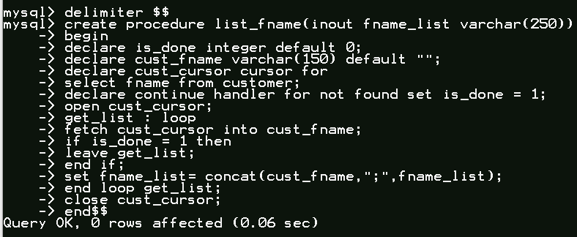

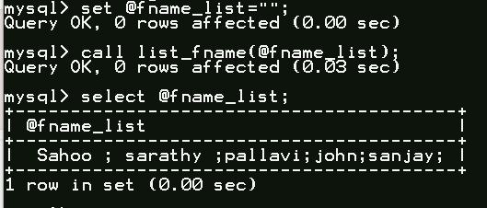

**Developing a Frontend**

The frontend should support

1. Addition, Modification and Deletion of records from any chosen table

2. There should be an window to accept and run SQL statement and display the result

